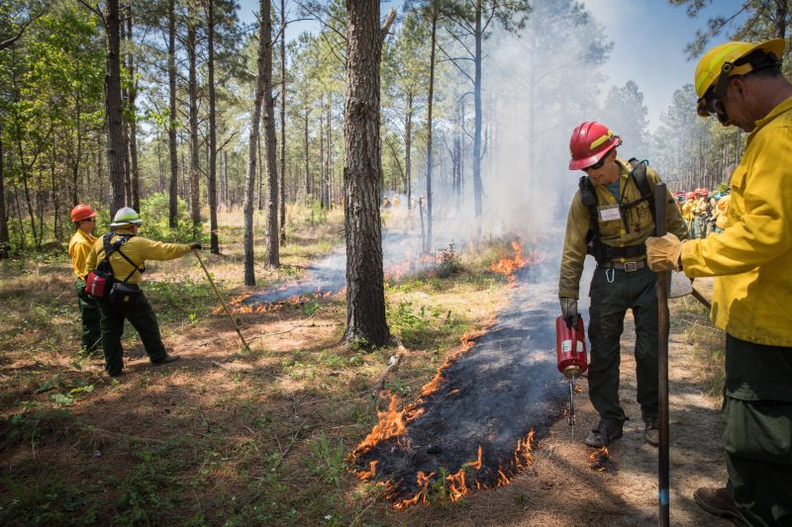
You Know Prescribed Fire is Good…
Now What?

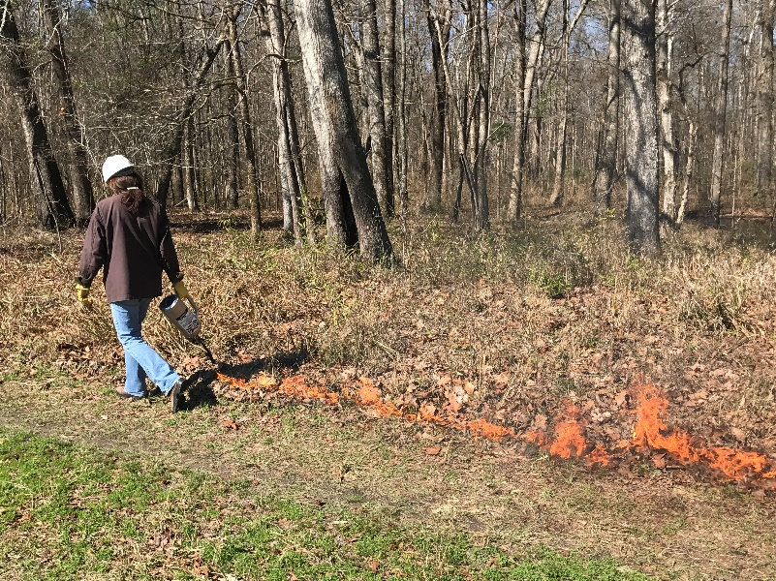
Join local experts to gain hands-on prescribed burning experience and learn the next steps to putting fire back on your land!
You Will Learn About:
- Safety
- Burn Objectives
- Writing a Burn Plan
- Financial Assistance
- Liability
- Becoming a Certified Burner
- Smoke Management
- Burn Weather
- Monitoring

Date: February 5, 2019*
Time: 10am-3pm
Location: Not sure yet, NC
Cost: $10, includes lunch
Who should attend: Landowners interested in prescribed fire, no experience necessary!
RSVP: Call Jane Doe at (555) 123-4567 or email janedoe@rxfire.com

Learn & Burn Workshop

- Gain hands-on prescribed burning experience
- Ask questions and learn from local experts
- Connect to resources and financial assistance to help you burn
- Meet other landowners interested in burning

Please wear closed-toe boots, long pants and sleeves, and cotton or other non-synthetic clothing. All other protective clothing and equipment will be provided.
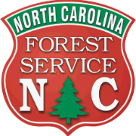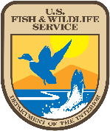

*If the weather does not allow for a burn, participants will be notified at least 24 hours beforehand and the workshop will be held on February 14, 2019. Additional details will be provided closer to the date.

